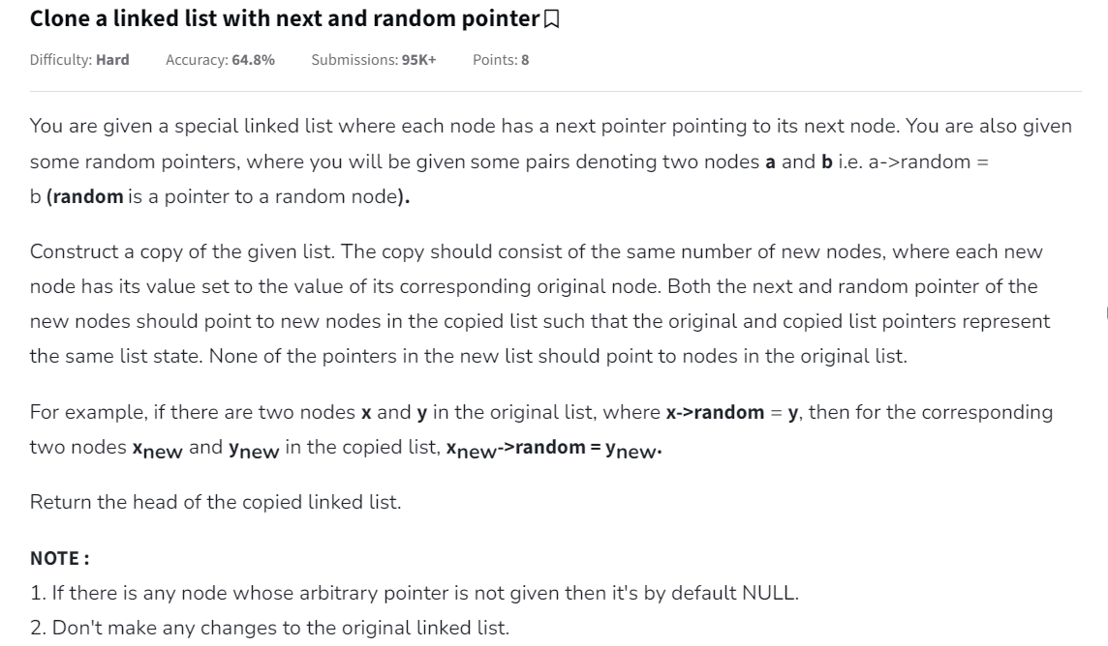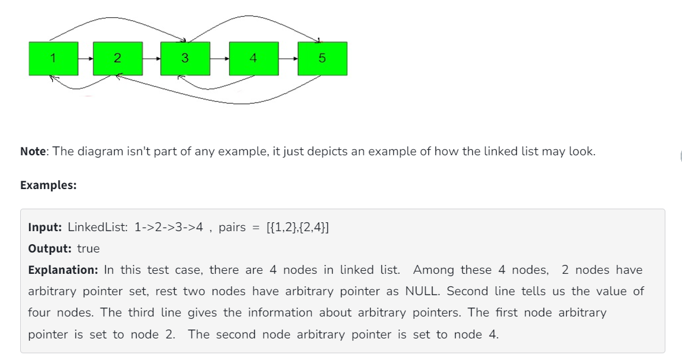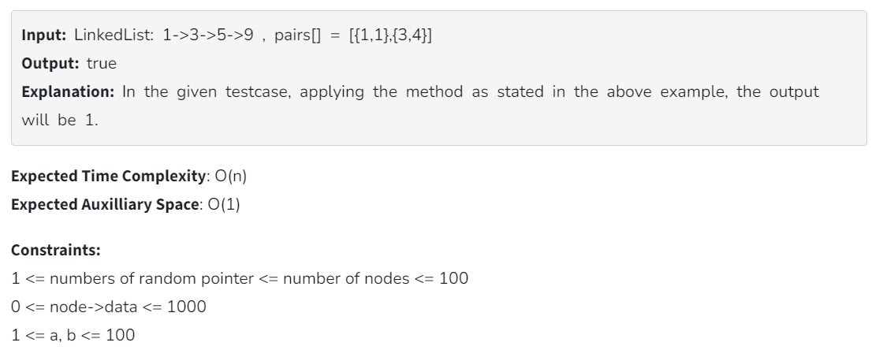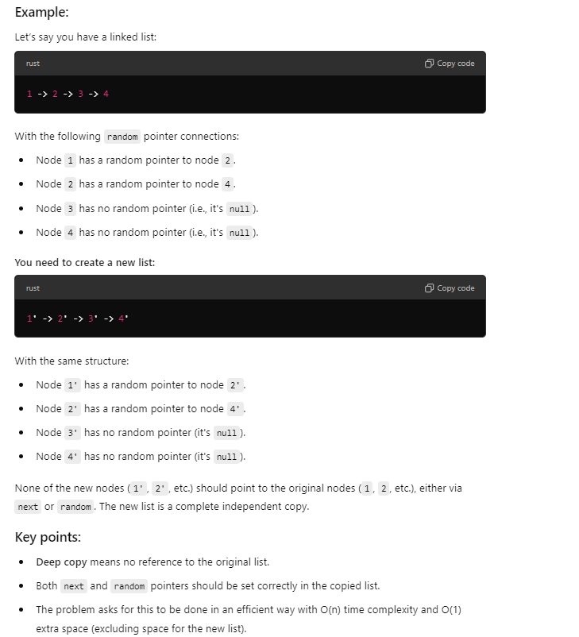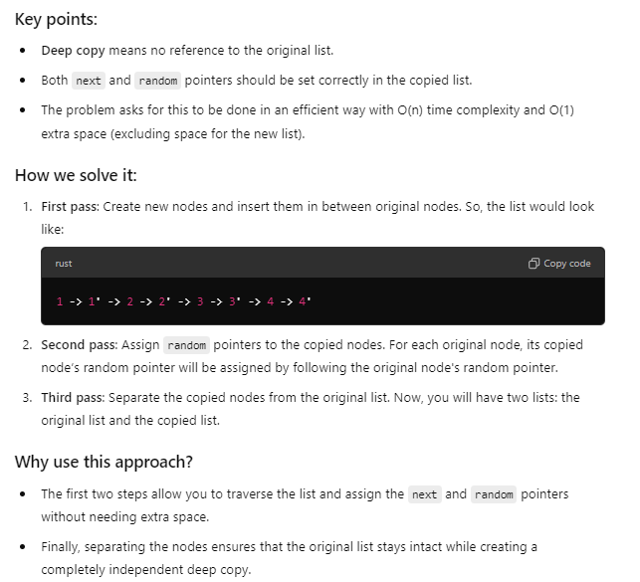

/\*Please note that it's Function problem i.e.

you need to write your solution in the form of Function(s) only.

Driver Code to call/invoke your function is mentioned above.\*/

/\*

class Node {

int data;

Node next, random;

Node(int d)

{

data = d;

next = random = null;

}

}\*/

class Solution {

// Function to clone a linked list with next and random pointer.

Node copyList(Node head) {

if (head == null) {

return null;

}

// Step 1: Create new nodes interleaved with the original nodes

Node current = head;

while (current != null) {

Node newNode = new Node(current.data);

newNode.next = current.next;

current.next = newNode;

current = newNode.next;

}

// Step 2: Assign random pointers to the new nodes

current = head;

while (current != null) {

if (current.random != null) {

current.next.random = current.random.next;

}

current = current.next.next;

}

// Step 3: Separate the copied nodes to form the new list

current = head;

Node newHead = head.next;

Node copy = newHead;

while (current != null) {

current.next = current.next.next;

if (copy.next != null) {

copy.next = copy.next.next;

}

current = current.next;

copy = copy.next;

}

return newHead;

}

}